Udsnit fra Michael Alan Reed: Waves of Commodification: A Critical Investigation Into Surfing Subculture. 1999 .

HISTORY AND ORIGINS OF
SURFING SUBCULTURE
Surfing has a long history in Polynesia, but it is a relatively recent arrival in much of the rest of the world. The practice of surfing and the social meaning associated with it were dramatically transformed over the last two centuries via its diffusion from Hawaii and its eventual adaptation by the West. The modern practice of surfing involves myriad rules, roles, myths and institutions which collectively create a distinctive subculture. However, this modern culture retains only suggestive fragments of its Hawaiian roots.

This first chapter briefly outlines how a ritual element of a pre-industrial culture on the most geographically isolated island in the world diffused throughout the world to become a highly visible and successful element of Western culture and economy. In particular, I will focus on the emergence of a distinctive subculture and mythology centered around Southern California surfing and the lifestyle it represents in the mass media. Surfing is now more than just a sport. It is a lifestyle, one of the hundreds of themed niche commodities which shape the mass market which is American popular culture. In short, the story of the development of this subculture is tied intimately to geography, colonization, mythology and economics.

Ancient Beginnings

Surfing apparently originated in Polynesia when the ancestors of the Polynesians and other Pacific Islanders started to move eastward out of Southeast Asia to colonize the Pacific. Their cultures were centered around the ocean and their famous ocean-going canoes which allowed a remarkable diffusion across vast open expanses of the world’s largest ocean. The evidence we rely upon today to date the emergence of surfing comes entirely from accounts of early European explorers and thus any attempt to accurately date surfing’s emergence is largely conjecture. Assuming that it developed early in the culture of Polynesia would place the date as early as 2,000 B.C. More likely, the sport reached its full technical and ritual development, including the riding of waves while standing, hundreds of years later in those places where geography conspired to create the best conditions for large surf, namely Hawaii and Tahiti. The first European explorers to see Hawaii and Tahiti found rich traditions of surfing already in place (Lueras 1984; Finney and Houston 1996). Archaeological evidence suggests that Hawaii had been reached by no later than AD 400 so we can safely assume that surfing existed for at least a thousand years in Hawaii before the Europeans invaded (Finney and Houston 1996:21).

The role of surfing in pre-contact Hawaii was central. Men, women, and children apparently participated with almost equal vigor. While the surfing abilities of King Kamehameha and his wife Ka’ahumanu were memorialized in ritual songs and chants, ordinary Hawaiians practiced the sport with equal relish (Lueras 1984; Kampion 1997). Westerners commented on the importance of the surfboard as personal property and one missionary even suggested its possession was as important to the Hawaiians as was the ownership of a light carriage to the Englishman of the day (Stewart, quoted in Finney and Houston 1996:27). In retrospect it is clear that European impressions of surfing reflected highly misguided notions about both the practice and meaning of surfing in Hawaii. Early engravings show the islanders in awkward, often impossible positions on the waves. Many of these engravings depicted naked native women (Figure 1).

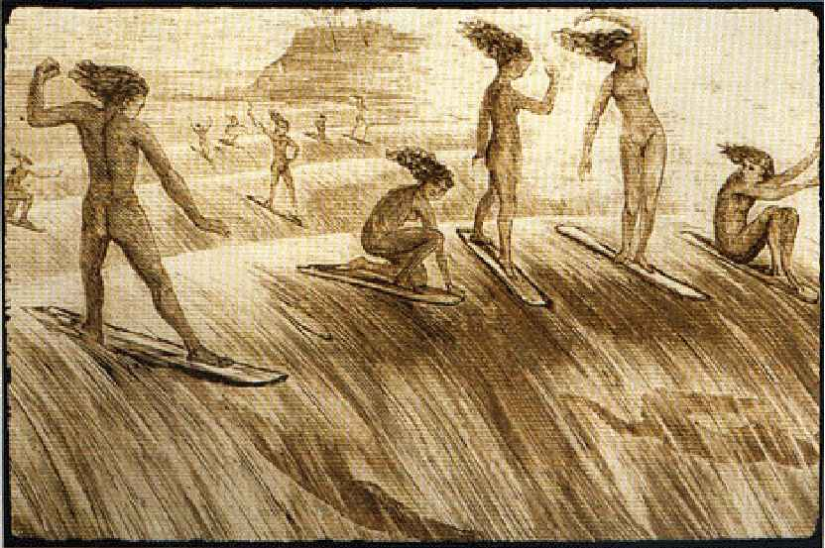
Most commentators simply categorized it as a sport in the European sense of the word: a recreation. They missed the point entirely. The Hawaiians relied on the sea for much of their livelihood and their relationship to the sea was probably the most important element of their spiritual life. Finney and Houston (Finney and Houston 1996:27) suggest that surfing was "the center of a circle of social and ritual activities that began with the very selection of the tree from which a board was carved and could end in the premature death of a chief - as was the result of at least one famous surfing contest in Hawaiian legend." In short, surfing was a central element of ancient Hawaiian life and was important to both sexes and all classes as recreation, ritual, and celebration.

European "Discovery" of Surfing

Regardless of when it originated, by the eighteenth century surfing had developed to a degree that amazed the European explorers and missionaries who first came into contact with it. The very first European descriptions of surfing come from the journals of Captain James Cook. While at anchor off Tahiti, Cook noticed a Tahitian in a dugout canoe catching and riding waves. Cook first suspected that the man had stolen something from one of his ships and was rapidly attempting an escape, but when the man paddled back out to do it again Cook began to understand: "I could not help concluding that this man felt the most supreme pleasure while he was driven on so fast and so smoothly by the sea" (Cook 1784, quoted in Duane 1996b:18). Later on the same voyage, Cook’s first lieutenant, James King, excitedly recounts watching Hawaiians ride standing on the surf: "their first object is to place themselves on the summit of the largest surge, by which they are driven with amazing rapidity toward shore" (1784, quoted in Finney and Houston 1996:21). Daniel Duane in his book-length essay on surfing culture, notes that Cook even mentions the apparent disregard of the surfer for the Europeans, despite the awe-struck gaping of many other Tahitian villagers. Duane argues that Cook and King were essentially correct in their analysis of surfing, attributing to it "words and thoughts that still cluster around it - absorbed in a clean swell , that eighteenth century Tahitian has no use for wealth, no yearning for greener grass, no fear of the imperialism at his doorstep" (Duane 1996b:18). Duane sees surfing as a kind of escape and he seems thrilled that Cook noticed this as well.

Whereas seamen like Cook and King saw the excitement and joy in surfing, most of the earliest European witnesses inscribed Western ideas onto surfing, categorizing it as either dangerous or unproductive. The missionary, William Ellis, hiking around the island of Hawaii in the 1820s notes that "the thatch houses of a whole village stood empty...daily tasks such as farming, fishing, and tapa-making were left undone while an entire community - men, women, and children - enjoyed themselves in the rising surf and rushing white water" (1831, quoted in Finney and Houston 1996:27). Already we see the conflict with Western notions of work and productivity that will cling to surfing throughout its history. Drew Kampion, in his history of surf culture, Stoked (1997: 33), argues that ‘surfing’s association with nakedness, sexuality, wagering, shameless exuberance, informality, ignorant joy, and freedom were counterproductive to the designs of the church fathers who, curiously, wound up owning most of the land in the islands." In addition to these notions of hedonism and pagan immorality were interpretations which focused on danger, bravery, and other masculine notions. One of the first of these comes from another missionary, George Washington Bates, who described surfers as "borne on the foaming crest of the mighty wave with the speed of the swiftest race-horse toward the shore, where a spectator looks to see them dashed into pieces or maimed for life" (Bates, quoted in Duane 1996b:18). Duane astutely suggests that these early European interpretations which focused on "risk, daring, and conquest" were more reflective of Europe than anything in Hawaiian surfing: "...the tropes of Western writers scrambling to give an alien sport familiar meaning" (Duane 1996b:19). Richard Henry Dana, the young Harvard dropout turned romantic seafarer, in his Two Years Before the Mast encounters a group of ‘sandwich Islanders," Hawaiians, living idly on the beach at San Diego. Although Dana does not recount any episodes of surfing, Duane (1996b:35) feels "safe assuming they used driftwood planks or felled trees as surfboards, or at least bodysurfed." When Dana’s captain attempts to hire the Hawaiians he has a remarkable conversation with them that again suggests surfing’s conflict between Western and Pacific Islander economic thought (Dana, quoted in Duane 1996b:124):

"What do you do here, Mr. Mannini?" asks the captain.

"Oh, we play cards, get drunk, smoke -- do anything we’re a mind to."

"Don’t you want to come aboard and work?"

"Aole! aole make mokou I ka hana. Now, got plenty money; no good, work. Mamule, money pau -- all gone. Ah! very good, work!
--maikai, hana hana nui!"

"
But you’ll spend all your money in this way, " says the captain.

"Aye! me know that. By-"em-by money pau -- all gone; then Kanaka work plenty."
So, in the middle of the eighteenth century, we see certain familiar ideas attaching to surfing and Polynesian culture - indolence, gluttony, and diffidence.

Mark Twain was probably the first tourist to actually attempt surfing while on a visit to Hawaii and write home about it. With his usual pluck and humor Twain paints a romantic picture, replete with references to naked heathens, for his stateside readers:

In one place we came upon a large company of naked natives, of both sexes and all ages, amusing themselves with the national pastime of surf-bathing. Each heathen...would wait for a particularly prodigious billow to come along; at the right moment he would fling his board upon its family crest and himself upon the board, a here he would come whizzing by like a bombshell!...I tried surf-bathing once, subsequently, but made a failure of it. I got the board placed right, and at the right moment, too; but missed the connection myself. The board struck shore in three-quarters of a second, without any cargo, and I struck the bottom about the same time, with a couple of barrels of water in me (Twain 1872, in Finney and Houston 1996:101).

Finally, he concludes that "none but natives ever master the art of surf-bathing thoroughly."

Such dispatches would eventually be part of the reason for surfing’s growth, but in the middle of the eighteenth century surfing was actually in an acute state of decline. Disease combined with missionary zeal against "pagan" practices, which included surfing, conspired to virtually eliminate most aspects of ancient Hawaiian culture. By the turn of the twentieth century only a handful of people practiced the little known sport of surf-riding. In 1892, Nathaniel B. Emerson, an author with an interest in the decline of native Hawaiian traditions stated that:

There are those living...who remember the time when almost the entire population of a village would at certain hours resort to the sea-side to indulge in, or to witness, this magnificent accomplishment. We cannot but mourn its decline. But this too has felt the touch of civilization, and today it is hard to find a surfboard outside of our museums and private collections. (Emerson 1892, quoted in Lueras 1984:54)

This was just two years before the overthrow of the Hawaiian monarchy and six years before the U.S. military annexation of Hawaii in 1898. Most authors agree that the sport barely survived colonization (Lueras 1984; Kampion 1997), but the seeds of surf culture, which included a healthy dose of resistance to Western norms regarding work, family, and spatial and temporal regimentation, would bear fruit during the sport’s 20th century renaissance.

Surfing’s Rebirth

The origins of a revolution that would change surfing from a largely Hawaiian sacred act into a haole recreation can be traced to Waikiki Beach on Oahu. It was here that the deliberate promotional efforts of a handful of Hawaiians, both haole and native, and the writings of journalists and advertisers, including Jack London, brought the sport to the attention of the West and an emerging tourist industry.

At the turn of the century the Waikiki beachfront, one of the original centers of ancient Hawaiian surfing, had already begun to be developed for tourism. Hotels were starting to crowd the beachfront. Among the few remaining surfers were a number of well connected haoles including journalist Alexander Hume Ford and local Irish-Hawaiian beachboy George Freeth. These men, along with a handful of native watermen including Duke Kahanamoku, would be instrumental in the sport’s survival.

During his visit to Hawaii, Jack London happened to befriend both Ford and Freeth. The two Hawaiians introduced London to surfing and in 1907 he published "A Royal Sport: Surfing at Waikiki" in Women’s Home Companion. Later, in 1910, Ford, concerned about increasingly limited access to the beachfront, organized the world’s first surfing association, The Outrigger Canoe Club. Ford secured a twenty year lease on an acre of beachfront property, built a symbolic grass hut, and charged annual dues for surfboard storage in lockers. The club’s stated purpose was

to give an added and permanent attraction to Hawaii and make Waikiki always the Home of the Surfer, with perhaps an annual Surfboard and Outrigger Canoe Carnival which will do much to spread abroad the attractions of Hawaii, the only islands in the world where men and boys ride upright upon the crests of the waves.(Ford, in Lueras 1984:70-71)

Here already are the signs of a dramatic change in the sport from its Hawaiian past. First, surfing in Western culture was immediately linked to the marketing of place and the promotion of tourism. Furthermore, women were no longer included. The Outrigger Canoe Club, though it did eventually include a number of women, was an avowedly male realm. Finally, as Drew Kampion (1997:36) points out, "the Outrigger was an almost strictly haole organization." In fact, three years after its formation a number of renegade members broke off and started a rival club called Hui Nalu. This new club was overwhelmingly composed of native Hawaiians. Although we can only guess at the motivations of Duke Kahanamoku, Hui Nalu’s first captain and founder, it seems apparent that a divide between the haoles and the more traditional surfers had emerged. Surfing’s association with wealthy white men had begun.

Jack London’s writings on surfing only deepen these initial themes. His report on surfing was characteristically masculine and did much to promote the sport in the United States. As in all of his works, London seemed to be unable to view nature, the sea in this case, as anything other than a realm for conquest and Men as nothing less than Judeo-Christian Gods:

Why, they are a mile long, these bull-mouthed monsters, and they weigh a thousand tons, and they charge in to shore faster than a man can run...And suddenly, out there where a big smoker lifts skyward, rising like a sea-god from out of the welter of spume and churning white...appears the dark head of a man...He is a Mercury - a brown Mercury. His heels are winged, and in them is the swiftness of the sea. In truth, form out of the sea he has leaped upon the back of the sea, and he is riding the sea that roars and bellows and cannot shake him from its back... He has "bitted the bull-mouthed breaker" and ridden it in, and the pride in the feat shows in the carriage of his magnificent body as he glances for a moment carelessly at you who sit in the shade of the shore. He is a Kanaka - and more, he is a man, a member of the kingly species that has mastered matter and the brutes and lorded it over creation. (London 1907, quoted in Finney and Houston 1996:106)

London eventually published much of his surfing material in The Cruise of the Snark (1911), further cementing surfing’s image as an extreme sport of conquest for men.

During the first three decades of the twentieth century surfing became a recognized part of the image of Hawaii sold to well-to-do travelers throughout the world. Cruise line travel brochures, carnivals, and even silent films helped to solidify the image of Hawaii and its people as exotic and different (Figure 2). Cruise line and hotel promotional brochures of the period focused on themes of paradise, difference, and implied sexuality (Goss 1993).
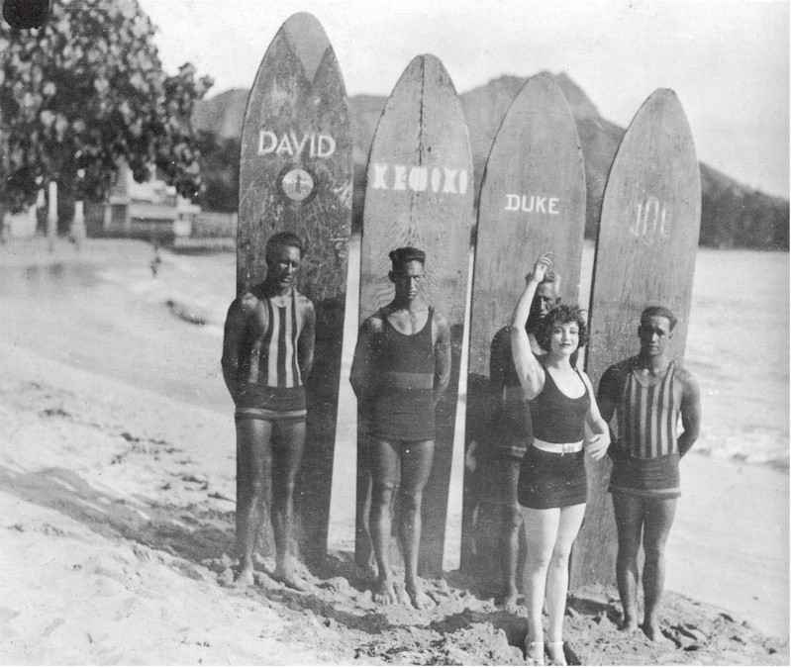
Many of these advertisements depict white tourist women surfing with Hawaiian beachboys (Figure 3), a tradition that continues to this day and which still has an association with sexuality, even male prostitution (Bone 1994). Many others simply show tourists posing with surfboards, the ultimate evidence of having been to the Otherside of the world.

Helping to solidify and spread this image were the exploits of a young Hawaiian athlete, Duke Kahanamoku, the founder of the aforementioned Hui Nalu Club. Duke led a life that likely did more to promote surfing and Hawaii than the efforts of all the others combined. Duke was first and foremost a fantastic athlete. Without training he broke numerous world swimming sprint records and he did this by impressive margins. Eventually, he broke the 100 and 200 meter sprint records and went on to astound the world at the 1912

Olympics, winning a gold medal while looking over his shoulder to see how far behind his opponents were. He did all of this without any formal training and stories about his remarkable abilities spread by newspaper to the U.S., Europe and Australia (Lueras 1984; Kampion 1997).

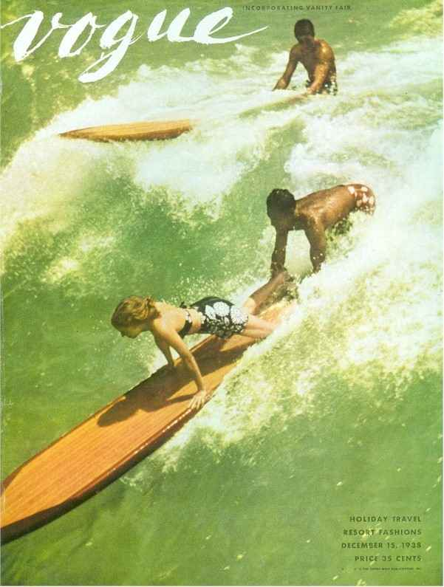
Duke’s real love, however, was surfing. He was a founding member of both of the world’s first surfing clubs and became so well known that he is now generally considered the "grandfather" of modern surfing. After his Olympic wins, Duke toured the world giving swimming and surfing demonstrations, visiting much of Europe, Australia, and both coasts of the United States. Despite all of this fame, his promotion of the sport, and Hawaii, became muddied by his association with Hollywood. Filmmakers decided he was the perfect figure for all sorts of swarthy foreigner roles - Arab kings, Apache and Hindu chiefs, and so forth. As a result Duke ended up spending nearly twenty years of his life living in and around Hollywood playing bit parts in major motion pictures. Not surprisingly, it wasn’t until 1948 that he actually played a Polynesian when he was cast opposite John Wayne in The Wake of the Red Witch (Figure 4).

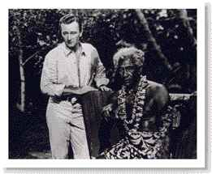
While Hollywood used Duke to represent the generic Other and rarely featured his surfing talents, surfing’s depiction in film can be traced back all the way to silent films. In the next chapter I focus in depth on the link between films and surfing as commodity, but in 1910 it was still almost fifty years before the advent of the surfing film and professional surf journalism. Expositions and tourism were still the most significant factors in surfing’s growth and worldwide diffusion (Figure 5).

Diffusion to California

It was during this period of press promotion and tourism that surfing spread to California, where the new commercial culture of surfing would eventually take final shape. This ironic reversal was linked from the start with the necessary expansion of capitalism and tourism. As we shall see, this pattern was to be repeated over and over

again throughout the subsequent spread of surfing. It was actually three Hawaiian princes attending military academy in San Mateo in 1885 who were probably the first persons to surf in California. They visited Santa Cruz and had redwood boards shaped so they could test the waves at the San Lorenzo rivermouth. Although Santa Cruz would become a beach resort soon thereafter, it seems that the exploits of these three Hawaiians went largely unnoticed and unexploited.

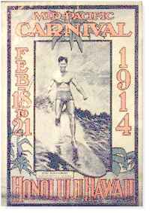
It was George Freeth who successfully transferred the idea of surfing to California when in 1907 he promoted the opening of the Los Angeles to Redondo Beach Railway by giving wave-riding demonstrations in front of thousands of spectators at Redondo Beach. This was the same year that London’s article appeared and the fortuitous combination, combined with Duke Kahanamoku’s first visits to Southern California in 1913, guaranteed that surfing would prosper. However, they also further linked surfing to commercial interests and the marketing of beachside places. All of this promotion increased the number of surfers in both Hawaii and California. In 1928 Tom Blake, inventor of the hollow surf board, organized the Pacific Coast Surfriding Championships at Corona Del Mar and in 1936 the Palos Verdes Surfing Club became California’s first surfing organization. According to Drew Kampion (1997), San Onofre became one of the first centers of the emerging California subculture.

He notes that in the years after the Depression surfing was one of a limited number of opportunities for recreation among the young people of Southern California. As the economy improved and cars became more common, a core group of surfers started congregating at the beach, camping sometimes for weeks, in a deliberate attempt to recreate the Waikikibeach scene, replete with grass skirts, ukuleles, and palm frond hats. Kampion’s description of this group notes the centrality of a symbol that remains an important element of surfing places to this day: "the surfers found a grass shack left behind by a Hollywood movie company, and that became a focal point" (Kampion 1997:48). Grass and palm frond shacks of this sort are constructed all over the world by surfers. Their importance as symbolic centers of surfing culture and elements in the promotion of tourist destinations was made particularly evident in 1998 when the San Diego Historic Site Board voted unanimously to designate a palm hut at Windansea beach in La Jolla, California a San Diego Historic Site (Figure 6). An application for its recognition as a National Historic Site is now in progress (Rodgers 1998a).

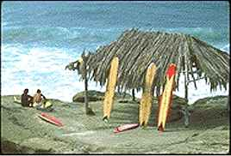
The construction and occupation of beach huts by surfers in California led almost immediately to confrontations with mainstream authorities who felt threatened by this appropriation of space. Evidence of this can be seen in the architecture of the Windansea hut itself. The Windansea hut, constructed originally in 1947, is unique in that it has no side walls. The architect of the hut explained that this was in order to prevent its destruction by police who had torn down similar shacks in Pacific Beach under the pretense that illegal "drinking and cavorting" were taking place inside their thin walls (Rodgers 1998a:B3).

Shortly after the emergence of San Onofre as a center of surfing culture, a new spot was discovered just north of Los Angeles. Malibu, a small point which faces south and receives the summer South Pacific typhoon swells, eventually would become the most influential focal point of Southern California surfing. However, in the early years of this century the point was the private property of the Samuel K. Rindge estate. His widow fought the construction of the road that is now State Highway 1, in the courts and with armed cowboys, but in 1926 construction began. For years access to Rancho Malibu was still limited to property owners and their business partners. Eventually Marblehead Development Company purchased and developed the land just north of Malibu and bit by bit the old Ranch was sold off, including tracts purchased by the state that would soon become Leo Carrillo State Beach. Many early Malibu surfers claim to have sneaked onto the Rindge property at one time or another, always keeping a watchful eye on Rindge’s armed ranch hands. Despite this early exclusion, by 1950 Malibu was the place to be if you were a Los Angeles county surfer, especially in the summer. Although the crowds were still small, they were growing. Throughout the boom time of the 1950s, a highly mobile and varied youth culture began to emerge. More and more young people, buoyed by greater access to expendable income and automobiles, were heading to the beach.

Hollywood Discovers Surfing

When this emerging beach culture was portrayed by Hollywood in Gidget (1959) and other beach films during the 1950s and 60s, surfing exploded in popularity. Brian Wilson and the music of the Beach Boys (who did not actually surf) reached even more of America. When the classic surf travel film The Endless Summer was nationally distributed in 1963, there were only a handful of countries where surfing was practiced. Today, as the result of the very successful commodification of surf culture, virtually every country that has a coastline has surfers and hosts surf-tourism and surfing themed products are used to sell everything from internet services to luxury sport-utility vehicles.

Gidget is the film that most dramatically changed everything for California surfing. Old time surfers talk today about a sea change in the water between 1959 and 1960 (Liquid Stage 1997). Prior to Gidget a Malibu surfer could pretty much ride any wave he wanted. Crowding was virtually unheard of and every surfer knew every other surfer at the home break. Gidget changed all that in one season by making surfing seem sexy and adventurous to millions of moviegoers. What is more, Gidget placed surfing within the reach of anyone. After all, apparently even a girl could do it. One year there were about twenty surfers at Malibu, the next year there were hundreds. Gidget was so popular that it led to five sequels and two television spin-offs. This is the film that many argue cemented America’s fascination with the mythical Southern California beach lifestyle. Surfing was now growing fast and becoming big business too. What’s more, the whole atmosphere of surfing changed. Crowding, territoriality ("localism"), and travel increased.

While the rest of America was watching Hollywood’s simplistic surf films and dancing to the music of the Beach Boys, surfers were making their own films, presenting them on the "four wall circuit" in high school gyms and community centers all along the California coast. The first of these low budget films to take on national importance was The Endless Summer, a film many still consider the only truly authentic surfing film.

Bruce Brown introduced The Endless Summer in 1964 in Santa Monica. It was a huge hit with the surfing crowd, but Hollywood distributors wouldn’t touch it. To prove it would sell to mainstream America, Brown rented an auditorium in downtown Wichita, Kansas, smack in the geographic center of the country. In spite of frigid winter weather conditions, the film sold out and was a smash hit for two solid weeks, outselling the theater’s previous engagement of My Fair Lady. Buoyed by his success, Brown debuted the film next in New York and critics raved. "the Fellini of the foam" said one; "Bergman of the boards" cried another (Lueras 1984:49).

Reportedly produced on less than $50,000, the film eventually grossed $30 million. Brown personally reaped around $8 million and became surfing’s first mogul. The film is technically simple. There is no dialogue since Brown, like other early surf film directors, generally performed live commentary while touring with his films. The plot is even simpler: two young California surfers set off to travel around the world following the summer and the surf. Filmed in a "down-to-earth" documentary style with a healthy dose of humor, the film apparently started a mad rush of surfing related tourism. The search for "the perfect wave" was on. Surfing magazines, the first of which was John Severson’s Surfer in 1960, soon made travel articles about "the search" a staple. Since then, his magazines have steadily increased their travel and international coverage.

The Surf Media and the Growth
of Professional Surfing
Magazines provided another means for the dissemination of surf culture. The circulation of Surfer went from around 5,000 in 1960 to roughly 100,000 in 1970. Today Surfer is one of an increasing number of specialized surf magazines, including Longboard, Surfing, Surfer Girl, Wahine, and The Surfer’s Journal, as well as numerous foreign publications. Most of these magazines dedicate the majority of their copy space to the coverage of professional surfing, which emerged during the 1970s.

The lineage of surfing competitions can be traced to ancient Hawaii, but it wasn’t until CBS discovered surfing in 1969, with the help of a young surfer named Fred Hemmings, that surfers could hope to make any money at their sport. The total prize money offered that first year was only $1,000 but surfing would never be quite the same and a deep split developed in as a result of the sport’s new competitive professionalism. At various times all three television networks would cover professional surfing, but television marketing was soon surpassed by the sponsorship of surf clothing and equipment manufacturers. By 1984, about $500,000 in total prize money was available on the international professional surfing tour (Lueras 1984). That figure has since risen to dramatically, with the top surfers earning hundreds of thousands each year. Moreover, lucrative sponsorships and apparel endorsement contracts now routinely exceed $1 million. But even more important than the money paid to the surfers is the surf media’s emphasis on professional surfers and the products these surfers promote.

While few surfers will ever compete in a contest, virtually all the articles and photographs in the surf media focus on professional surfers. In addition, extensive magazine advertising and the sponsorship of contests and individual athletes by surfing retailers and manufacturers creates a massive industry focused around the marketing of surfing style to the world of consumers. The surf wear industry alone is now worth $1.7 billion and includes such familiar names as Gotcha, Billabong, Quicksilver, Rusty, Stussy, Mossimo, and Pacific Eyes and Tees (Earnest 1999:C1). All of these companies, along with the successful movie makers and magazines, managed to capitalize on the symbolic appeal of surfing and in turn they helped to shape the image of surfing, transforming an iconoclastic subculture into a powerful element of what some commentators are calling "liberation marketing" (Frank 1997:44). Even very mainstream products are now often marketed with surfing imagery (Figure 7).

